**Project Documentation**

DS Jobs

# 1. Project Overview

This project analyses job roles data using Excel and Power BI to find insights of job market.”

# 2. Tools Used

* Microsoft Excel
* Power BI

# 3. Dataset

* Source: "sample data"
* Data contains: Job title, Salary starting ,Salary estimate, Job description ,Company name, Date, Description, Rating, City, State, Headquarter city, Headquarter Country, Min employees, Max employees, Founded year, Type of ownership, Industry, Sector, Min revenue, Max revenue, Competitors.

# 4. Steps Followed

* + Cleaned data in Excel
  + Used Excel formulas and Pivot Tables for basic analysis
  + Imported cleaned data into Power BI
  + Built dashboards using charts, slicers, and KPIs

# 5. Key Insights

* + 432 total number of companies.
  + Public type of ownership has more job titles.
  + The state CA has more job titles.
* Highest number of companies and industries was founded in 2012.
* Overall maximum revenue hits at 15 USD.

6. **Screenshots**

Sample screenshots

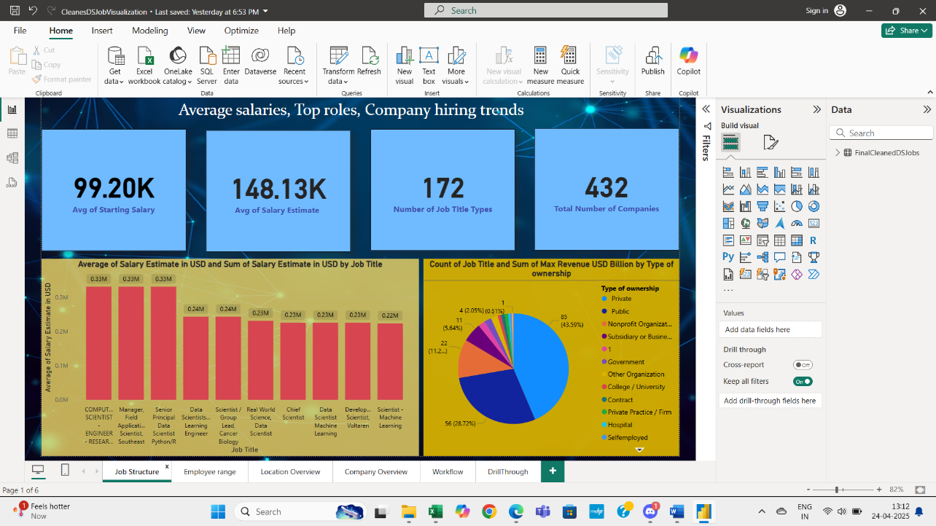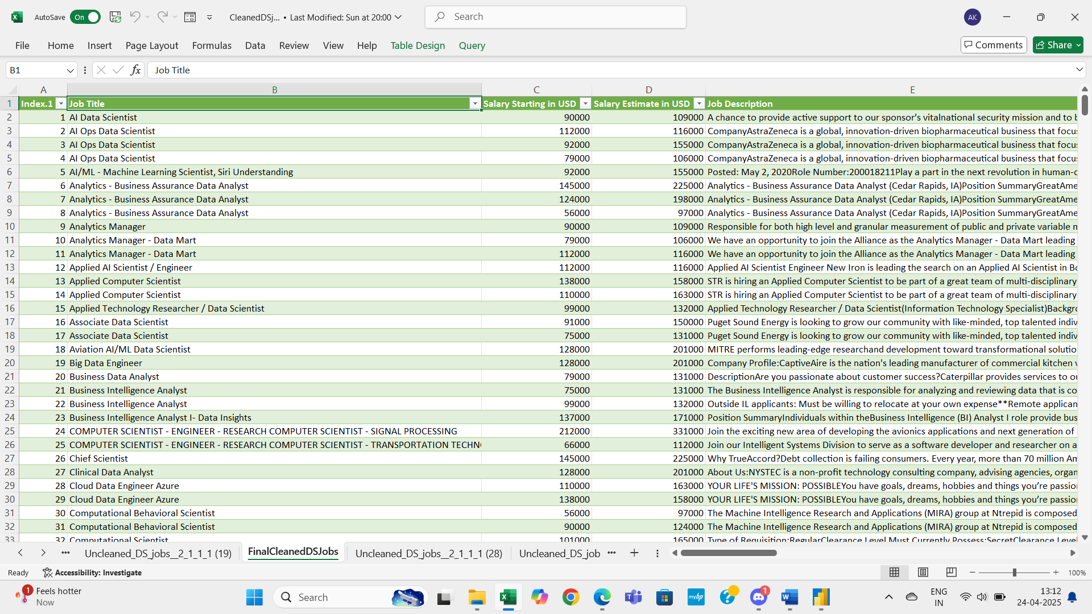

# 7. Files Included

* ‘CleanedDSJobs.xlsx’ – Cleaned data and basic analysis
* ‘CleanesDSJobVisualization.pbix’– Power BI dashboard
* ‘UncleanedDSJobs.xlsx’--Uncleaned Data

# 8. How to Use

* Open ` CleanedDSJobs.xlsx` to view the cleaned data.
* Open ` CleanesDSJobVisualization.pbix` in Power BI Desktop to explore the visuals.